**Set access tokem**

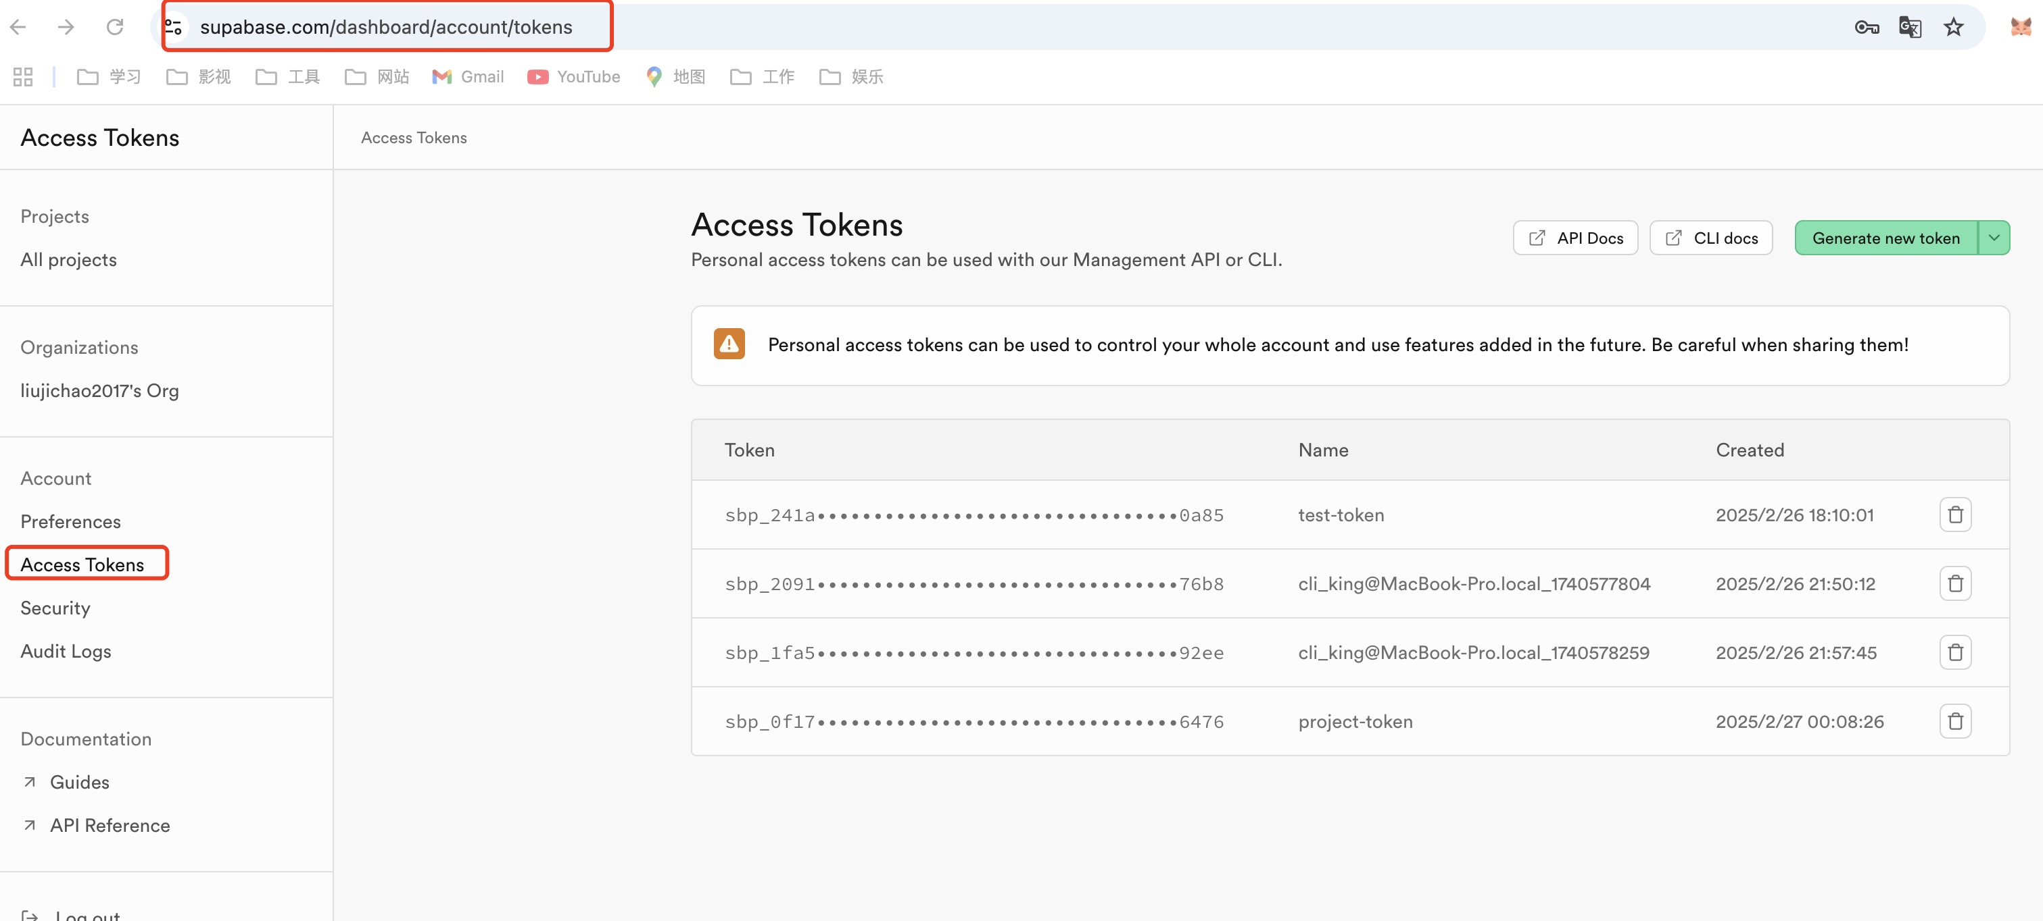

**Set project url , project api keys**

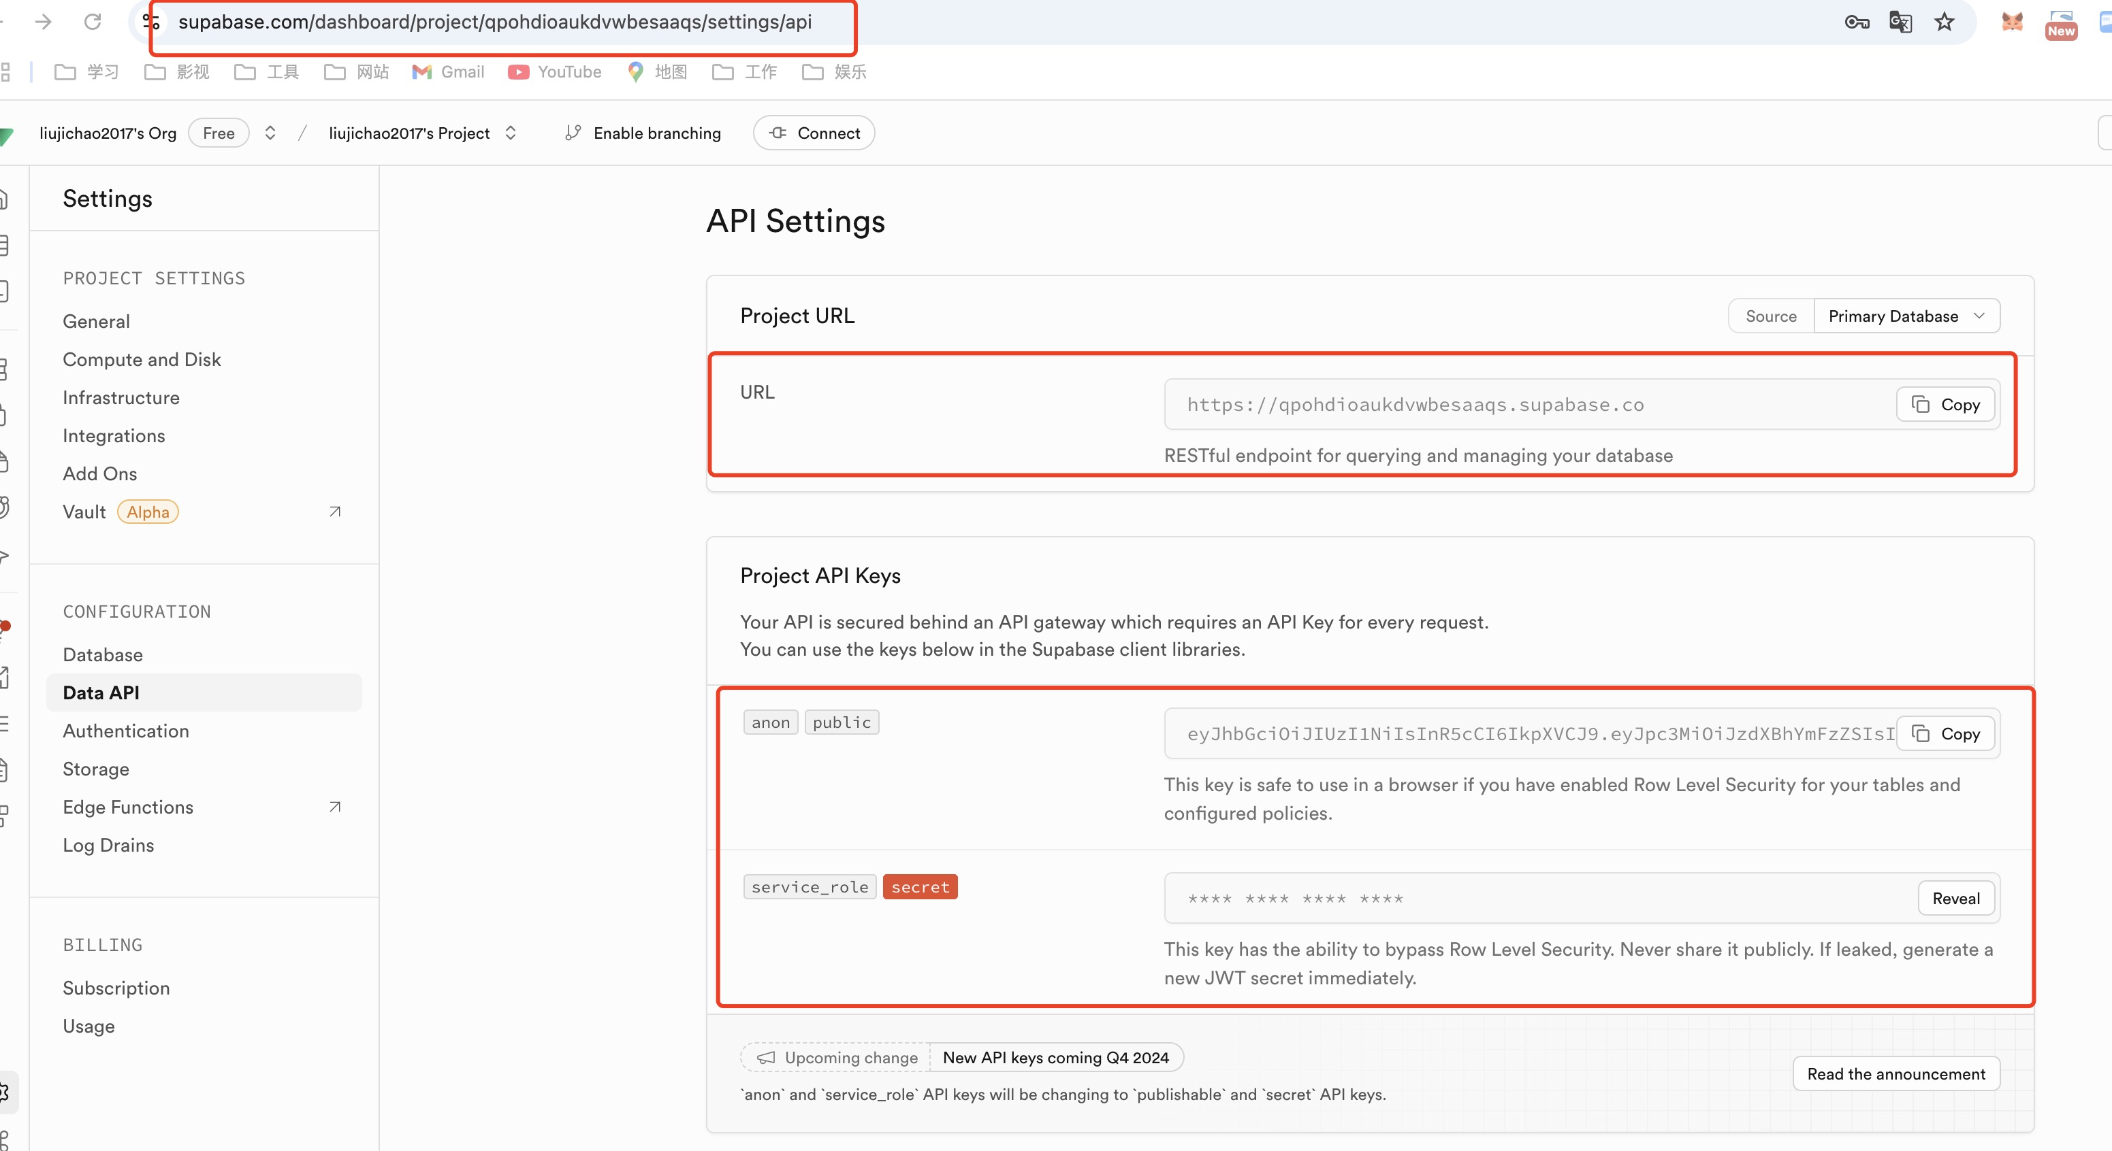

**Set database pwd**

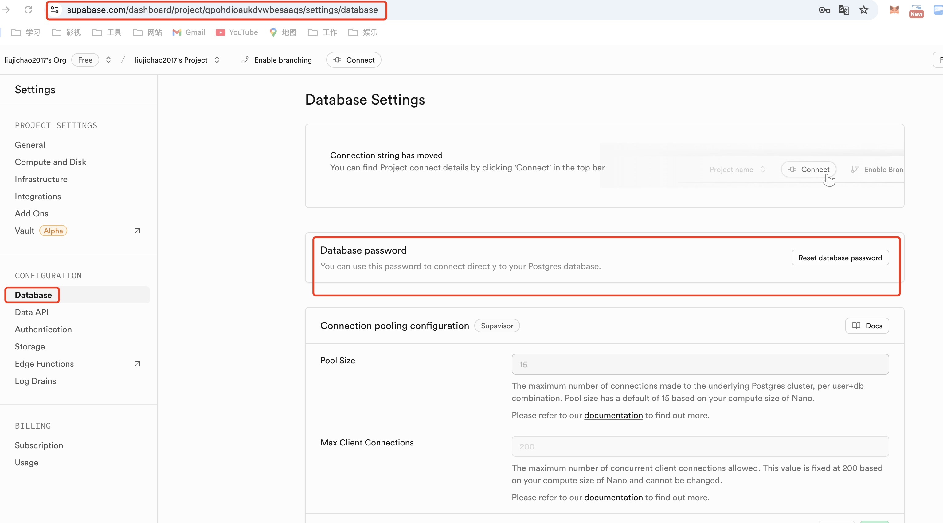

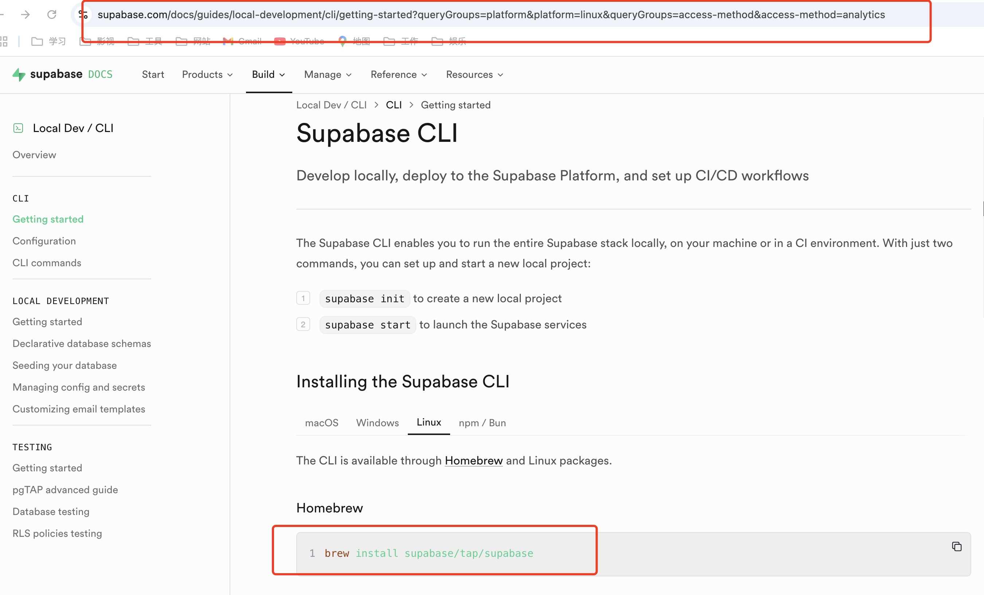

**Follow the steps on this website to install the supabase cli scaffolding**

[**https://supabase.com/docs/guides/local-development/cli/getting-started?queryGroups=platform&platform=linux&queryGroups=access-method&access-method=analytics**](https://supabase.com/docs/guides/local-development/cli/getting-started?queryGroups=platform&platform=linux&queryGroups=access-method&access-method=analytics)

**Configure the required information into the project .env file**

